 | INDIAN INSTITUTE OF TECHNOLOGY ROORKEE
Programming in C and C++ (CSC-101)

Assignment 5 60 marks

Note : (No function / matrix/ array are allowed to be used)

Garv
25114035

Q-1) Print the square of numbers in a zigzag pattern, where even-numbered rows go left to right and odd-numbered rows go right to left. User gives the value of N which is the number of rows and columns

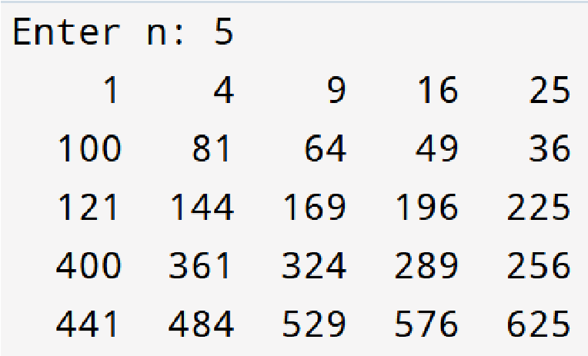
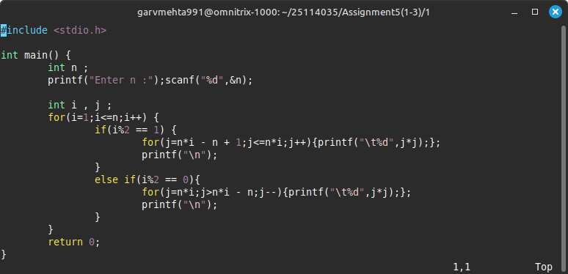

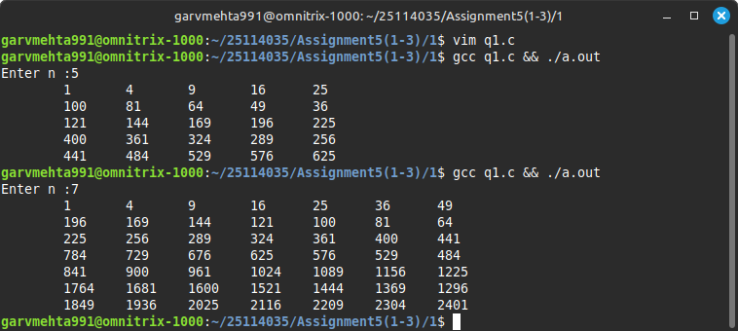

Q-2) Write a C program to print a hollow pyramid with its reflection below. The program
should take an integer n as input, representing the height of the pyramid. The output should look like this:

Input: n = 5

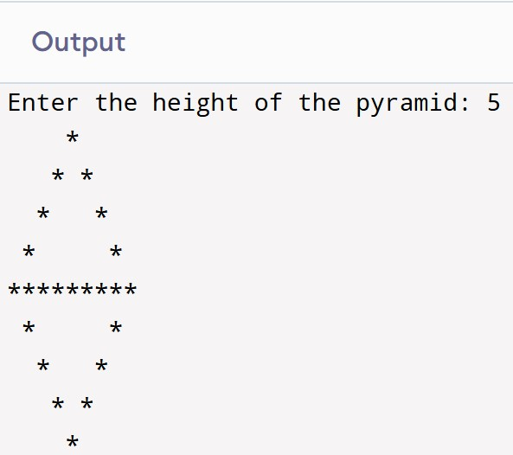

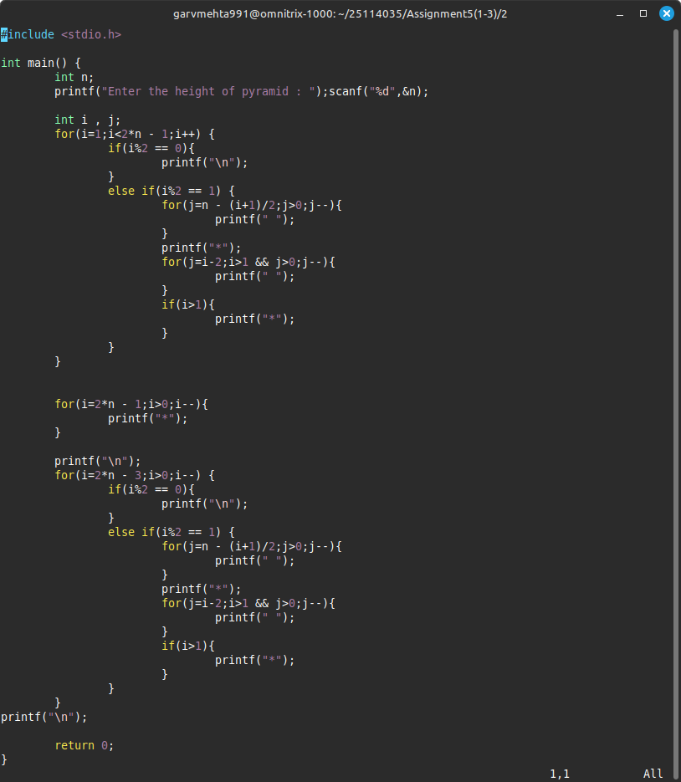

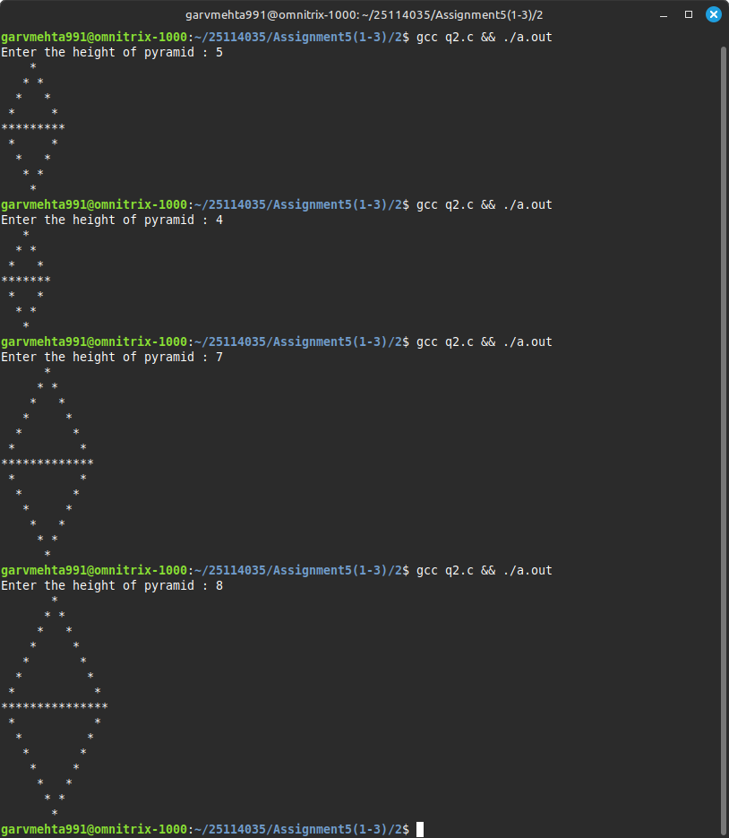

Q-3)A sequence of integers is called “magical” if the absolute difference between every pair of consecutive numbers is exactly 1, and none of the numbers in the sequence is less than 1. Your task is to write a program that first accepts an integer N representing the length of the sequence (where 2 ≤ N ≤ 100), then reads N integers that form the sequence. The program should determine whether the sequence is magical according to the rules described. If the sequence is magical, it should print the maximum number found in the sequence. If the sequence is not magical, the program should identify and print all the numbers that violate the magical conditions.
For example, given the input sequence 1 2 3 2 1, the output should indicate the sequence is magical and print the maximum number, 3. For the input sequence 1 2 3 5 2 1, the output should indicate the sequence is not magical and print the number 5 that breaks the sequence.

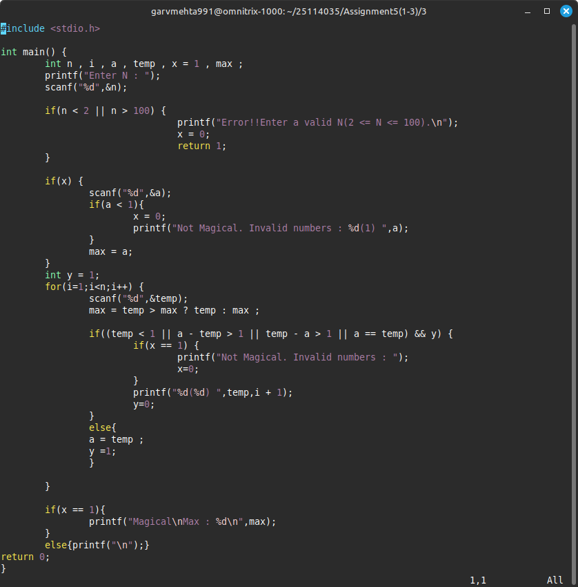

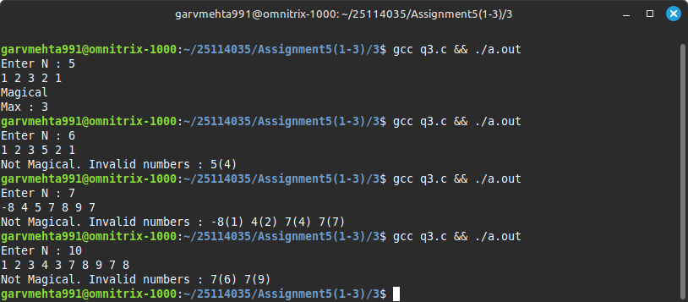

Q-4)Write a C program to calculate mean, median, sum, and maximum of integers entered by the user. The user continues to enter the numbers in ascending order and when it wants to stop it presses “0”. You are not allowed to use arrays or functions other than main.

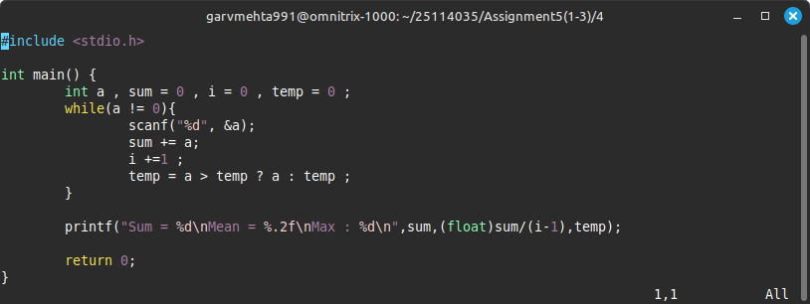

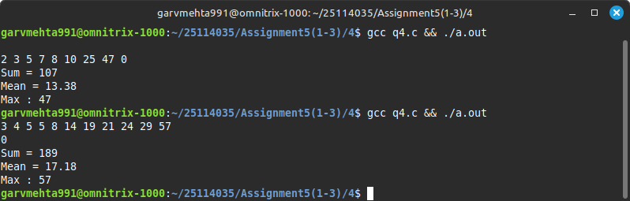

Q-5)Write a C program that first reads two integers: the number of elements n and the spacing integer k. Then, it reads n integers one by one from the user. Your program should calculate the maximum sum of a non-empty subsequence of the given integers such that any two selected numbers in the subsequence are at least k indices apart in the original sequence.
You are not allowed to use arrays or functions other than main. The program should use only a single for loop and primitive variables to compute the answer efficiently.
Input:

n=4 k=2

3 2 7 10

Maximum sum = 13

In the example above, the sequence is [3, 2, 7, 10] and spacing k = 2. Valid subsequences where every chosen pair of elements are at least 2 indices apart include {3,7}, {3,10}, and {2,10}. Among these, {3,10} gives the maximum sum 13.

Q-6). Write a C program to print Pascal's Triangle up to n rows. Pascal's Triangle is a triangular array where each number is the sum of the two numbers directly above it.
The first few rows of Pascal’s Triangle look like this:
